**Voice Controlled Arduino Robot**

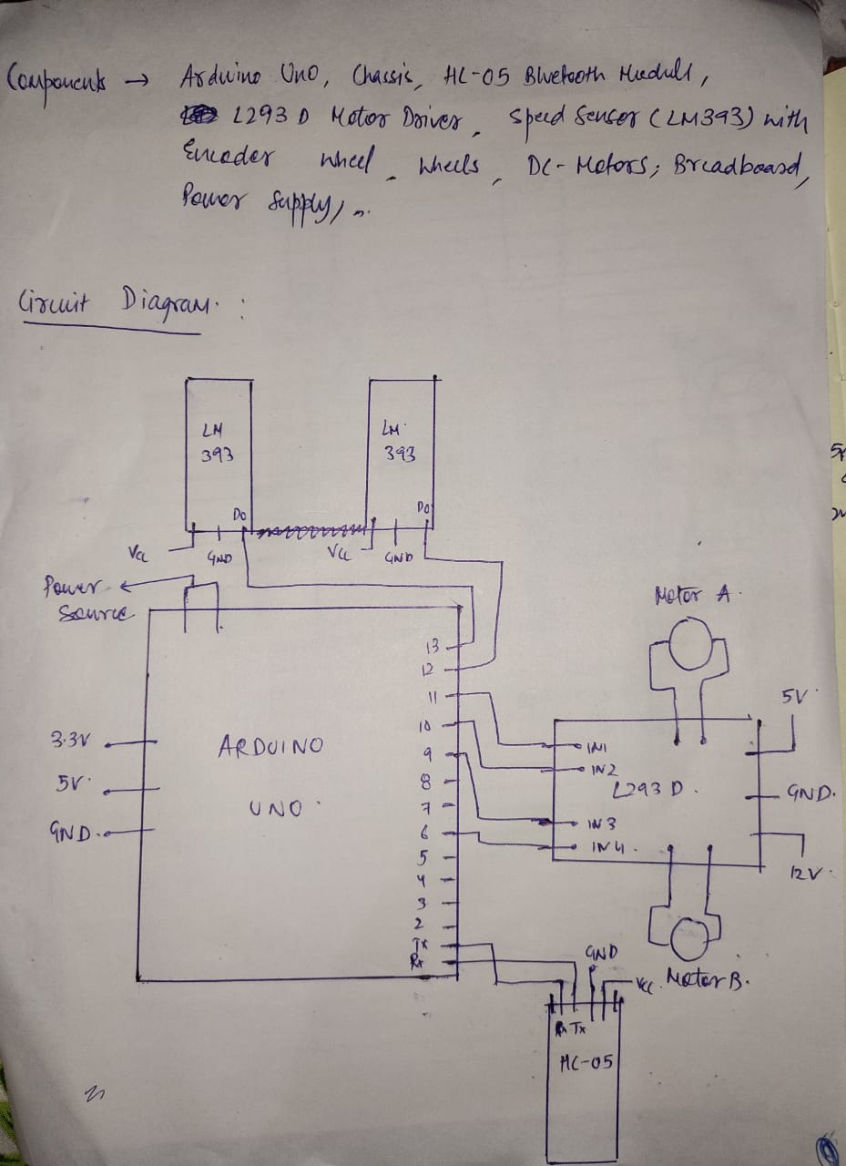

Code :-

|  |
| --- |
| /* Voice controlled Robot */  /* PLZ NOTE : the code has been hard-coded for some distances because of the incorrect serial communication b/w bluetooth and arduino .  Voice Commands were exact in case of serial communication b/w computer and arduino so i have to hard-code . plz excuse me for that */  /* Ex. when i say forward it takes the input something else mixed of symbols and characters . i tried everything but not successful */  **int** in1 = **9**; //motor1  **int** in2 = **6**; //motor1  **int** in3 = **10**; //motor2  **int** in4 = **11**; //motor2  **int** flag = **0**;  **int** sensor = **13**;  **unsigned** **long** start_time = **0**;  **unsigned** **long** end_time = **0**;  **int** steps=**0**;  **float** steps_old=**0**;  **float** temp=**0**;  **float** rps=**0**;  **float** r;  **float** radius=**3**;  **float** c= **2**\***3.14**\*radius ;  **float** t=**0**;  **void** **setup**()  {  Serial.begin(**9600**);  pinMode(**9**,OUTPUT);  pinMode(**8**,OUTPUT);  pinMode(**10**,OUTPUT);  pinMode(**11**,OUTPUT);  pinMode(sensor,INPUT_PULLUP);    Serial.println(" RPS - 0.00");  }    **void** **loop**()  {  **if** (Serial.available()) {  flag = Serial.read(); //reading input  Serial.println(flag);  /* hardcoded as if we speak "forward 50" then it sends input 8(ascii code as 56) , we speak "reverse" it sends input 1(ascii value 49). etc. */    **if** (flag == **48**) //stop  {  analogWrite(**9**,**0**);  analogWrite(**10**,**0**);  analogWrite(**6**,**0**);  analogWrite(**11**,**0**);  }  **else** **if** (flag == **49**) //reverse  {  analogWrite(**9**,**0**);  analogWrite(**10**,**0**);  analogWrite(**6**,**255**);  analogWrite(**11**,**255**);    delay(**1000**);    analogWrite(**9**,**0**);  analogWrite(**10**,**0**);  analogWrite(**6**,**0**);  analogWrite(**11**,**0**);  }    **else** **if** (flag == **50**) //left  {  analogWrite(**9**,**200**);  analogWrite(**10**,**0**);  analogWrite(**6**,**0**);  analogWrite(**11**,**0**);  delay(**1000**);  analogWrite(**9**,**0**);  analogWrite(**10**,**0**);  analogWrite(**8**,**0**);  analogWrite(**11**,**0**);    }  **else** **if** (flag == **51**) //right  {  analogWrite(**9**,**0**);  analogWrite(**10**,**200**);  analogWrite(**6**,**0**);  analogWrite(**11**,**0**);  delay(**1000**);  analogWrite(**9**,**0**);  analogWrite(**10**,**0**);  analogWrite(**6**,**0**);  analogWrite(**11**,**0**);    }  **else** **if** (flag == **52**) // forward 10  {  analogWrite(**9**,**255**);  analogWrite(**10**,**255**);  analogWrite(**6**,**0**);  analogWrite(**11**,**0**);    r=claculateRPM();  t=**10**/(c*r);  delay(t\***1000**);    analogWrite(**9**,**0**);  analogWrite(**10**,**0**);  analogWrite(**6**,**0**);  analogWrite(**11**,**0**);  }    **else** **if** (flag == **53**) //forward 20  {  analogWrite(**9**,**255**);  analogWrite(**10**,**255**);  analogWrite(**6**,**0**);  analogWrite(**11**,**0**);  r=claculateRPM();  t=**20**/(c*r);  delay(t\***1000**);    analogWrite(**9**,**0**);  analogWrite(**10**,**0**);  analogWrite(**6**,**0**);  analogWrite(**11**,**0**);  }  **else** **if** (flag == **54**) //forward 30  {  analogWrite(**9**,**255**);  analogWrite(**10**,**255**);  analogWrite(**6**,**0**);  analogWrite(**11**,**0**);  r=claculateRPM();  t=**30**/(c*r);  delay(t\***1000**);    analogWrite(**9**,**0**);  analogWrite(**10**,**0**);  analogWrite(**6**,**0**);  analogWrite(**11**,**0**);  }  **else** **if** (flag == **55**) //forward 40  {  analogWrite(**9**,**255**);  analogWrite(**10**,**255**);  analogWrite(**6**,**0**);  analogWrite(**11**,**0**);  r=claculateRPM();  t=**40**/(c*r);  delay(t\***1000**);    analogWrite(**9**,**0**);  analogWrite(**10**,**0**);  analogWrite(**6**,**0**);  analogWrite(**11**,**0**);  }  **else** **if** (flag == **56**) //forward 50  {  analogWrite(**9**,**255**);  analogWrite(**10**,**255**);  analogWrite(**6**,**0**);  analogWrite(**11**,**0**);  r=claculateRPM();  t=**50**/(c*r);  delay(t\***1000**);    analogWrite(**9**,**0**);  analogWrite(**10**,**0**);  analogWrite(**6**,**0**);  analogWrite(**11**,**0**);  }  **else** **if** (flag == **57**) //forward 100  {  analogWrite(**9**,**255**);  analogWrite(**10**,**255**);  analogWrite(**8**,**0**);  analogWrite(**11**,**0**);  r=claculateRPM();  t=**100**/(c*r);  delay(t\***1000**);    analogWrite(**9**,**0**);  analogWrite(**10**,**0**);  analogWrite(**8**,**0**);  analogWrite(**11**,**0**);  }  }    }  //function to calculate rps  **float** **claculateRPM**(){  start_time=millis();  end_time=start_time+**1000**;  **while**(millis()<end_time)  {  **if**(digitalRead(sensor))  {  steps=steps+**1**;  **while**(digitalRead(sensor));  }  }  temp=steps-steps_old;  steps_old=steps;  rps=(temp/**20**);    Serial.println(rps);  **return** rps;  } |

Model

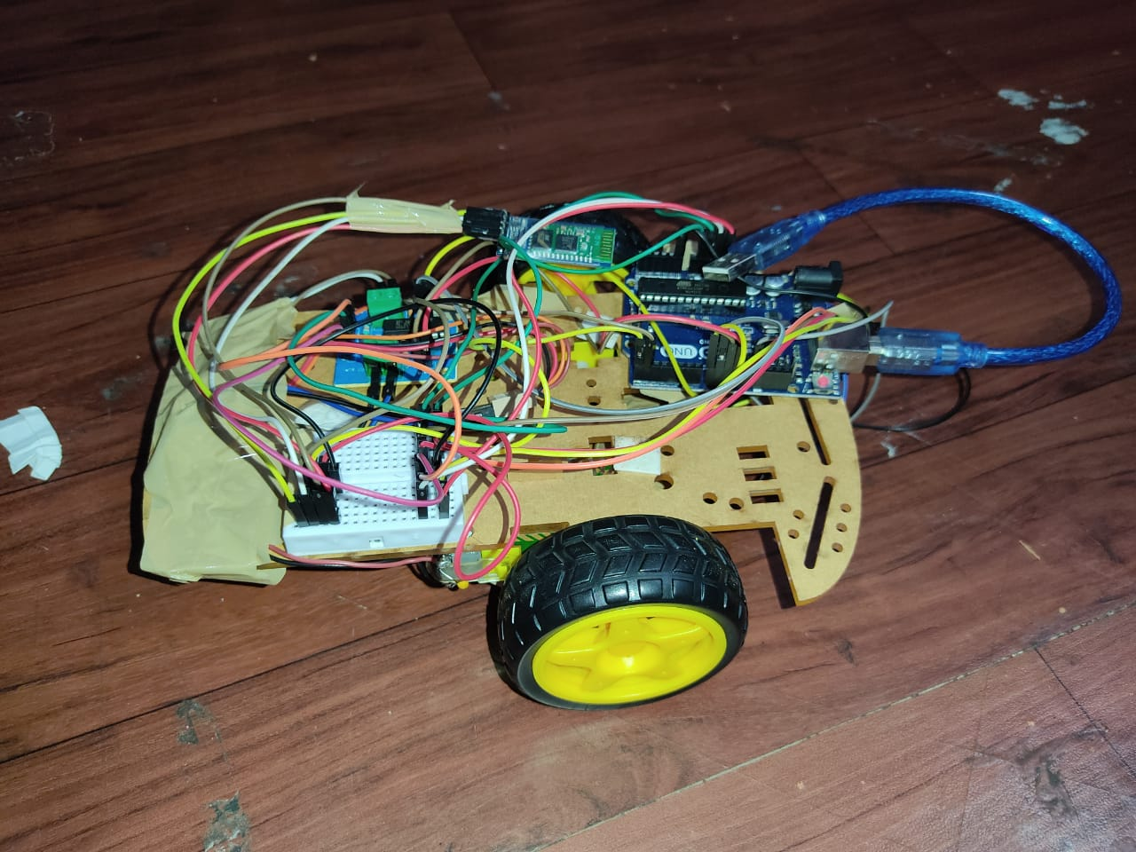

Video Attached .